For Immediate Release:
March 23, 2020

Media Contact:
Carrie Leishman
Office: (302) 738.2545
Cell: (410) 937-4606
Carrie@delawarerestaurant.org

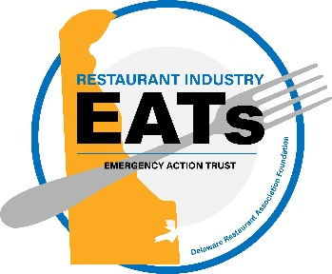
Industry Relief Fund to Provide Direct Financial Aid to Restaurant Industry Workers

Newark, DE – The Delaware Restaurant Association, through it’s 501c3 foundation (Delaware Restaurant Association Educational Foundation/DRAEF) is announcing the formation of a new industry relief fund to aid workers displaced by the recent restaurant industry shutdowns. ‘Restaurant Industry E.A.T.s’ (Emergency Action Trust) will provide direct cash support to the many restaurant industry workers that have been laid off due to the recent restaurant restrictions in Delaware. The DRAEF will be funding the new Trust with donations from individual donors and grants from local private foundations and corporate partners. The Beer & Benevolence Foundation, created by Dogfish Head founders Sam & Mariah Calagione, is providing an initial $50,000 donation, with another $50,000 donated when the fund reaches $150,000. Their company will also donate profits from the sales of hand sanitizer the Dogfish Head Distilling Co. is currently producing for the State of Delaware to the E.A.T.s fund.
“Our company has benefitted from the support of the local restaurant community for the past twenty-five years,” explained Mariah Calagione, Dogfish Head Co-Founder and Communitarian. “As a beer supplier to the industry, and restaurant operators ourselves, we know the important role restaurants play in our local economy. We appreciate the Delaware Restaurant Association’s quick response to the current crisis facing hospitality workers here in Delaware and encourage those who are able to join us in supporting the E.A.T.s fund.”

Along with an anonymous individual donation, the Trust has already raised over $65,000. ‘Text to donate’ and online links will be made public for individual donors in the next few days.

A record 11,000 Delawareans filed for unemployment in the first weeks following the restaurant shutdowns in Delaware. Delaware’s restaurant workers (over 49,000) make up 10% of the state’s workforce, and contribute over $2.2 billion in annual sales. It is anticipated that as many as 25,000 will file for unemployment benefits in Delaware. The Coronavirus shuttered hundreds of restaurants in the first few days of the government mandated restaurant shutdowns, immediately displacing thousands of its valuable workforce – and with 78% of individuals live paycheck to paycheck, immediate support is our workforce and their families is critical.
"We are seeing mass layoffs due to COVID-19 and I am blown away by the humanity of our amazing industry leaders and restaurant operators – each one asking the same first question - "what can be done for my employees?" Together, we hope to raise awareness and funds to provide grants to full-time restaurant workers in Delaware who are dependent on wages to cover basic living expenses and provide for their families. Our goal is to provide $500 grants to as many qualifying displaced workers as possible. Our initial goal of raising $1 million would provide 2,000 grants to those most in need.”
-- Carrie Leishman, President & CEO, Delaware Restaurant Association

Restaurants are truly the cornerstone of every neighborhood, community, and provide a space to gather and connect for every type of occasion, but now is the time to give back to the industry that serves us all. Those wishing to support restaurant workers and donate to the relief fund can make a donation at http://www.delawarerestaurant.org/relief. Any amount will be accepted and a tax-deductible donation letter will be generated upon receipt of all donations.

The restaurant industry E.A.T.s relief fund will accept applications on a rolling basis via an online application at http://www.delawarerestaurant.org/relief and begin distributing funds on April 6th - four weeks after the restaurant shutdowns began. Funds will be directly transferred into electronic Paypal accounts of applicants. Questions/comments can be directed to DEeats@delawarerestaurant.org.

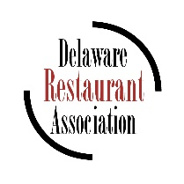
The Delaware Restaurant Association is the state trade association dedicated to supporting, educating, and advocating for Delaware’s foodservice industry. Delaware’s 2,000 restaurants employ over 49,000 people with an economic impact of over $2 billion in annual sales. Delaware restaurants are the largest small business employer in the state and the largest component of Delaware’s tourism industry.

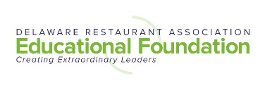
The Delaware Restaurant Association Educational Foundation is the non-profit, philanthropic arm
of the Delaware Restaurant Association, dedicated to developing training initiatives for Delaware’s
youth and workforce.

###

